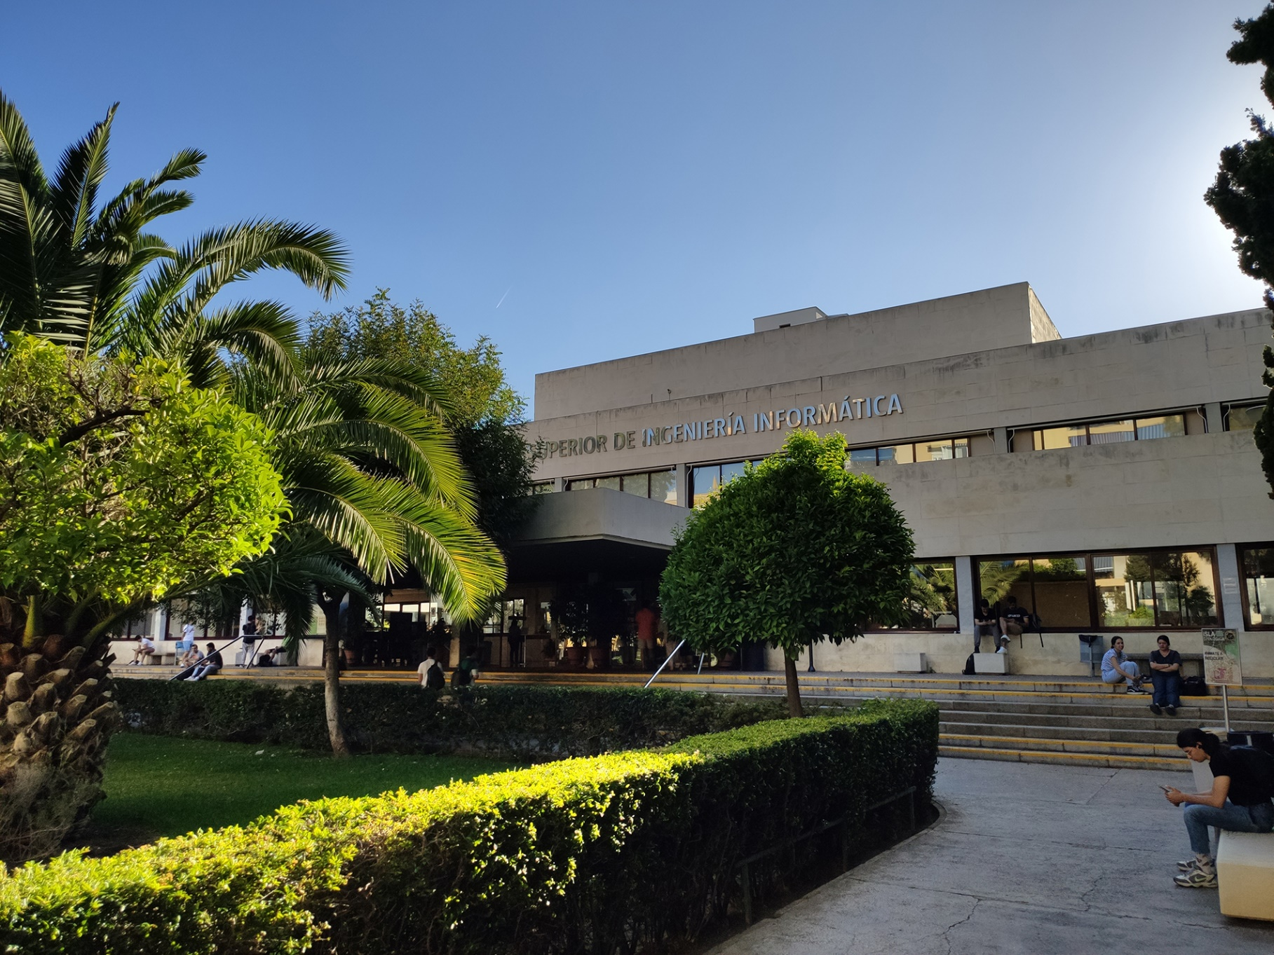

|  |
| --- |
| Planning  Report  Student #4 |
| Members:  Ismael Ruiz Jurado  (ismruijur@alum.us.es) |
| 16-02-2023  Group: C1.02.10  Repository: https://github.com/jescarcon/Acme-L3-D01-23.1 |



Table of Contents

Executive Summary 3

Version History 4

Introduction 5

Contents 6

Conclusions 7

Bibliography 8

# Executive Summary

In this document you will find a list of the tasks that have been performed in order to fulfil the requirements in th first deliverable, and also a budget with the total cost required to carry the previous tasks out.

# Version History

|  |  |  |
| --- | --- | --- |
| Version | Date | Description of changes |
| V1.0 | 16/02/2023 | Making of the report |

# Introduction

In the next section I will introduce a table for the individual tasks of the project. Every new row includes the title of the task, a succinct description of the task, the role, the planned time for doing the task and the final time for that task, along with their github issue related to the task and two tables made with excel to calculate the expected salary.

The cost stablished for the task is 30 €/h for the manager and analyst role tasks and 20 € for the developer ones.

# Contents

This table explains, for each task, its description, its asignee and his role, its planned time and its actual time completing the task.

|  |  |  |  |  |
| --- | --- | --- | --- | --- |
| Title | Succinct Description | Assignee/s and Role/s | Planned Time | Actual Time |
| Functional requirements #1 | Modify the anonymous menu so that it shows an option that takes the browser to the home page of your favourite web site. The title must read as follows: “〈id-number〉: 〈surname〉, 〈name〉”, where “〈id-number〉” denotes your DNI, NIE, or passport number, “〈surname〉” denotes your sur-name/s, and “〈name〉” denotes your name/s. | Ismael Ruiz Jurado / Developer and Analyst | 25’ | 15’ |
| Analysis Report | Create Analysis Report | Ismael Ruiz Jurado / Analyst | 30’ | 40’ |
| Planning Report | Create Planning Report | Ismael Ruiz Jurado / Analyst | 30’ | 35’ |

In GitHub, the issues are like this:

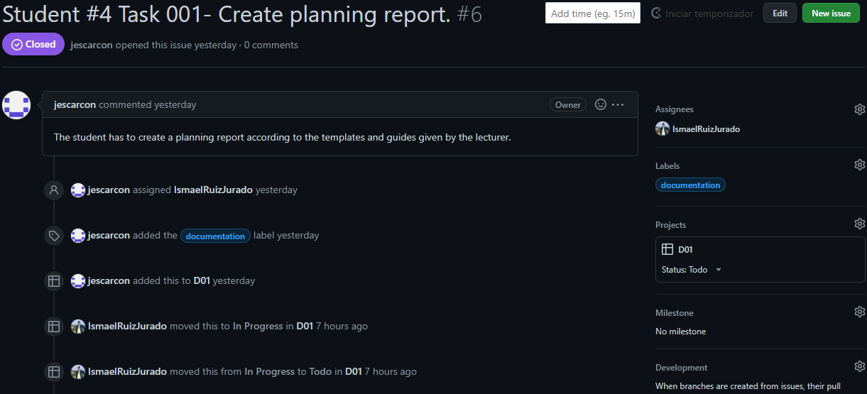

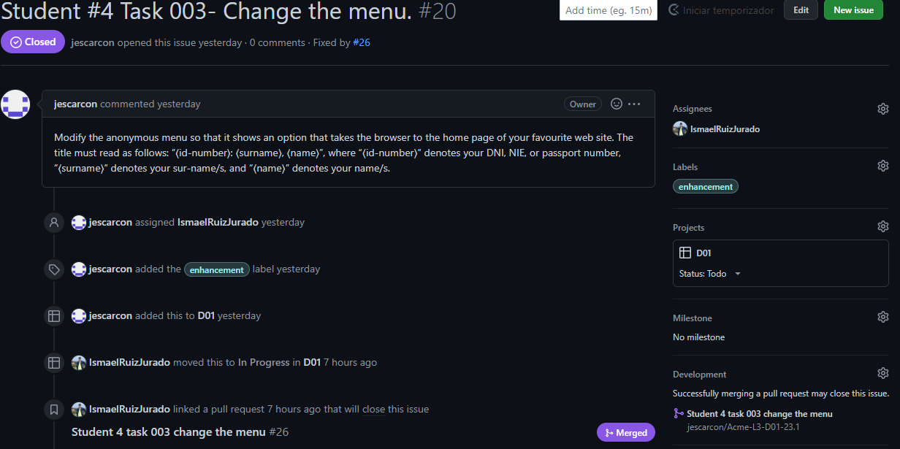

The next tables represent the salary that I should receive for doing the tasks. Remember that the tasks that I have done in a developer role are paid with 20€/h and the analyst tasks are paid with 30€/h, as stated in the Introduction.

|  |  |  |
| --- | --- | --- |
| Developer Tasks | Time (min) | Cost(€) |
| Functional Requirement #1 | 15 | 5 |

|  |  |  |
| --- | --- | --- |
| Analyst Tasks | Time(min) | Cost(€) |
| Planning Report | 40 | 13,33333333 |
| Analysis Report | 35 | 11,66666667 |

# Conclusions

After making the planning and seeing the actual time spent on the tasks, I can see that on this deliverable the tasks were very simple, especially the ones that needed to develop code.

# Bibliography

Intentionally blank.